2025_02_20
Coupled Endothelial and Smooth Muscle Cell Model
This computational model simulates shear-induced NO signalling in endothelial (EC) and smooth muscle cells (SMC) to study arterial behaviour. The SMC model includes actin-myosin cycling, intracellular Ca²⁺, and NO signalling, while the EC model captures shear stress-induced NO production. Coupling these models predicts SMC contraction under varying shear stress. Implemented in CellML, the model provides insights into arterial function and vascular regulation.
- All codes have been edited and validated.

- The EC component (4) and SMC components (1,2,3) are coupled.

- The involved and edited CellML Models:
- Main_Coupled_SMC_Model.cellml
- Intracellular_Calcium_SMC.cellml
- NO_cGMP_Signalling_SMC.cellml
- Coupled_Main_EC_Model
- EC_SMC_Units.cellml

- The main file is “Main_Coupled_SMC_Model.cellml”.

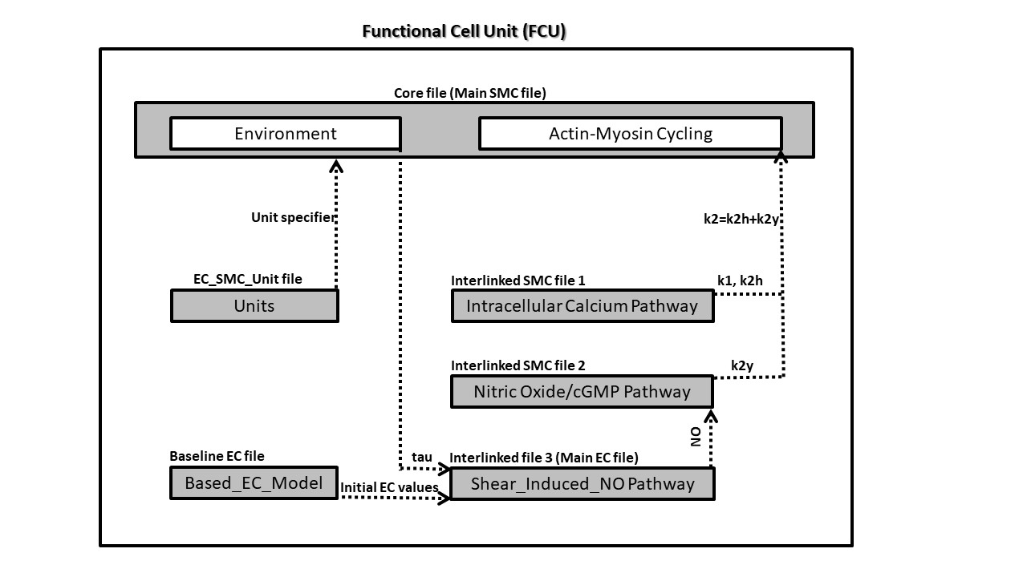
Figure 3. Arrangement of the model showing in CellML scripts involved.

